**Course: Advance Bio Informatics**

**Module Title: Semantic Web**

**Module No: 67**

**Semantic Web**

An extended web of m/c readable information and automated services that amplify the Web far beyond current capabilities. The current Web extension that allows you to find, share, and combine info more easily.

**Semantic Web Framework:** Organize, interpret, meaning to data. **It** provides a mechanismfor use of that meaning.Web of documents, onlyunderstandable by humans.Web of data that can beread and understood bysoftware agents.

**Biomedical Data**

• Unique

• Heterogeneous

• Highly dynamic.

• Lacks a clear and theoretically grounded definition.

• Focus on data, info, knowledge, but do not provide an adequate definition of these terms.

**Motivation**

It has large amount of scientific literature. Manually access and all relevant information extraction is impossible.

**Solution**

Text mining techniques on scientific literature. Public online databases containing (supplemental) data and rules between data.

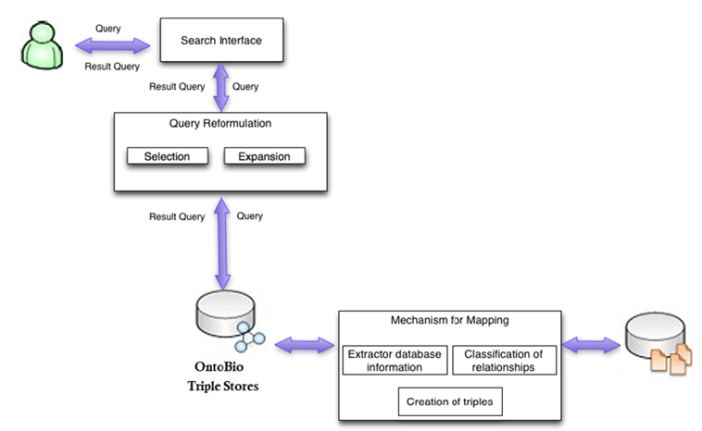

**Data Sources in Bio Informatics**



